How to Write a Lab Report
Ask you teacher for advice, but if in doubt, keep it simple, choose a memory experiment (you don't get extra marks for originality). Remember to make sure your research in psychology adheres to ethical guidelines. You will also be likely to write your paper according to APA style.

Ethical Considerations in Research
If the study involves any of the following, due consideration should be made about (1) whether to conduct the study, (2) how best to protect the participants’ rights.
• Psychological or physical discomfort.
• Invasion of privacy. If you are researching on private property, such as a shopping mall, you should seek permission.
• Deception about the nature of the study or the participants’ role in it. Unless you are observing public behavior, participants should be volunteers and told what your research is about. If possible obtain informed consent. You should only withhold information if the research cannot be carried out any other way.
• Research with children. In a school you will need the head teacher's consent and, if (s)he thinks it is advisable, the written consent of the children's’ parents/guardians. Testing children in a lab requires the written consent of parents/guardians.
• Research with non-human animals. Experimentation with animals should only rarely be attempted. You must be trained to handle and care for the animals and ensure that their needs are met (food, water, good housing, exercise, gentle handling and protection from disturbance). Naturalistic observation poses fewer problems but still needs careful consideration; the animals may be disturbed especially where they are breeding or caring for young.
When conducting investigations, never:
• Insult, offend or anger participants.
• Make participants believe they may have harmed or upset someone else.
• Break the law or encourage others to do it.
• Contravene the Data Protection Act.
• Copy tests or materials without permission of the copyright holder.
• Make up data.
• Copy other people’s work without crediting it.
• Claim that somebody else’s wording is your own.
Infringement of any ethical guidelines may result in disqualification of the project.

Research Report Structure
Title page, abstract, references and appendices are started on separate pages (subsections from the main body of the report are not). Use double-line spacing of text, font size 12, and include page numbers.
The report should have a thread of argument linking the prediction in the introduction to the content in the discussion.

1. Title Page:
This must indicate what the study is about. It must include the IV & DV. It should not be written as a question.

2. Abstract: (you write this last)
The abstract comes at the beginning of your report but is written at the end.
The abstract provides a concise and comprehensive summary of a research report. Your style should be brief, but not using note form. Look at examples in journal articles. It should aim to explain very briefly (about 150 words) the following:
• Start with a one sentence summary, providing the aim and rationale for the study.
• Describe participants and setting: who, when, where, how many, what groups?
• Describe the method: what design, what experimental treatment, what questionnaires, surveys or tests used.
• Describe the major findings, which may include a mention of the statistics used and the significance levels, or simply one sentence summing up the outcome.
• The final sentence(s) outline the studies 'contribution to knowledge' within the literature. What does it all mean? Mention implications of your findings if appropriate.

3. Introduction:
The purpose of the introduction is to explain where your hypothesis comes from. You must be explicit regarding how the research outlined links to the aims / hypothesis of your study.
• Start with general theory, briefly introducing the topic.
• Narrow down to specific and relevant theory and research. Two or three studies is sufficient.
• There should be a logical progression of ideas which aids the flow of the report. This means the studies outlined should lead logically into your aims and hypotheses.
• Do be concise and selective, avoid the temptation to include anything in case it is relevant (i.e. don't write a shopping list of studies).
• Don’t turn this introduction into an essay.
• Don’t spell out all the details of a piece of research unless it is one you are replicating.
• Do include any relevant critical comment on research, but take care that your aims remain consistent with the literature review. If your hypothesis is unlikely, why are you testing it?
AIMS: The aims should not appear out of thin air, the preceding review of psychological literature should lead logically into the aims.
• Write a paragraph explaining what you plan to investigate and why. Use previously cited research to explain your expectations. Later these expectations are formally stated as the hypotheses.
• Do understand that aims are not the same as the hypotheses.
HYPOTHESES: State the hypothesis and make sure it is clear, concise and includes the variables under investigation.

4. Methodology
- Assume the reader has no knowledge of what you did and ensure that he/she would be able to replicate (i.e. copy) your study exactly by what you write in this section.
- Write in the past tense.
- Don’t justify or explain in the Method (e.g. why you choose a particular sampling method), just report what you did.
- Only give enough detail for someone to replicate experiment - be concise in your writing.
USE THE FOLLOWING SUBHEADINGS:
Participants –
Identify the target population (refer to a geographic location) and type of sample. Say how you obtained your sample (e.g. opportunity sample). Give relevant details, e.g. how many, age range.

Materials –
Describe the materials used, e.g. word lists, surveys, computer equipment etc. You do not need to include wholesale replication of materials – instead include a ‘sensible’ (illustrate) level of detail.

Procedure –
Describe the precise procedure you followed when carrying out your research i.e. exactly what you did. Describe in sufficient detail to allow for replication of findings. Be concise in your description and omit extraneous / trivial details. E.g. you don't need to include details regarding instructions, debrief, record sheets etc.

5. Results:
The results section of a paper usually present the descriptive statistics followed by inferential statistics. Avoid interpreting the results (save this for the discussion).
Make sure the results are presented clearly and concisely. A table can be used to display descriptive statistics if this makes the data easier to understand. DO NOT include any raw data.

Use APA Style
- Numbers reported to 2d.p. (incl. 0 before the decimal if < 1.00, e.g. “0.51”). The exceptions to this rule: Numbers which can never exceed 1.0 (e.g. p-values, r-values): report to 3d.p. and do not include 0 before the decimal place, e.g. “.001”.
- Percentages and degrees of freedom: report as whole numbers.
- Statistical symbols that are not Greek letters should be italicised (e.g. M, SD, t, X², F, p, d).
- Include spaces either side of equals sign.
- When reporting 95% CIs (confidence intervals), upper and lower limits are given inside square brackets, e.g. “95% CI [73.37, 102.23]”

What information to include:
  - The type of statistical test being used.
  - Means, SDs & 95% confidence intervals (CIs) for each IV level. If you have four to 20 numbers to present, a well-presented table is best, APA style.
  - Clarification of whether no difference or a significant difference was found the direction of the difference (only where significant).

6. Discussion:
• Relate your results to your hypothesis, e.g. is it supported or rejected?
• Compare you results to background materials from the introduction section. Are your results similar or different? Discuss why/why not.
• How confident can we be in the results? Acknowledge limitations, but only if they can explain the result obtained. If the study has found a reliable effect be very careful suggesting limitations as you are doubting your results. Unless you can think of any confounding variable that can explain the results instead of the IV, it would be advisable to leave the section out.
• Suggest constructive ways to improve your study if appropriate.
• What are the implications of your findings? Say what your findings mean for the way people behave in the real world.
• Suggest an idea for further researched triggered by your study, something in the same area, but not simply an improved version of yours. Perhaps you could change one of the variables (IV or DV).
• Concluding paragraph – Finish with a statement of your findings and the key points of the discussion (e.g. interpretation and implications), in no more than 3 or 4 sentences.

7. References:
The reference section is the list of all the sources cited in the essay (in alphabetical order). It is not a bibliography (a list of the books you used).
In simple terms every time you refer to a name (and date) of a psychologist you need to reference the original source of the information.
If you have been using textbooks this is easy as the references are usually at the back of the book and you can just copy them down. If you have been using websites then you may have a problem as they might not provide a reference section for you to copy.
References need to be set out APA style:
Books
Author, A. A. (year). Title of work. Location: Publisher.
Journal Articles
Author, A. A., Author, B. B., & Author, C. C. (year). Article title. Journal Title, volume number(issue number), page numbers
A simple way to write your reference section is use Google scholar. Just type the name and date of the psychologist in the search box and click on the 'cite' link.
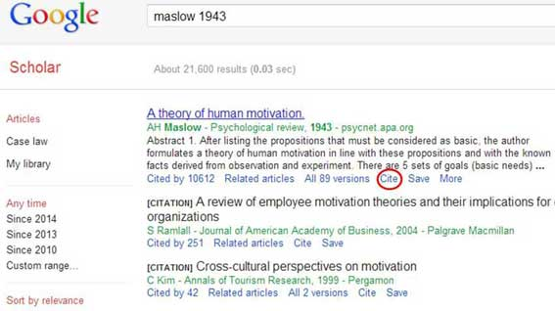
Next, copy and paste the APA reference into the reference section of your essay.
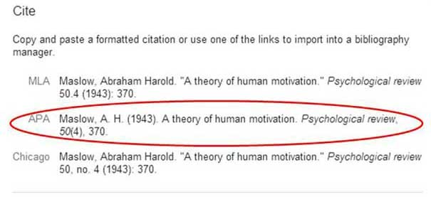
Once again remember that references need to be in alphabetical order according to surname.

